MPCA: Lab - 4

Name: Rithvik Rajesh Matta
SRN: PES2UG23CS485
Sec: H

- Write an ALP using ARM7TDMI to add n numbers bytewise.

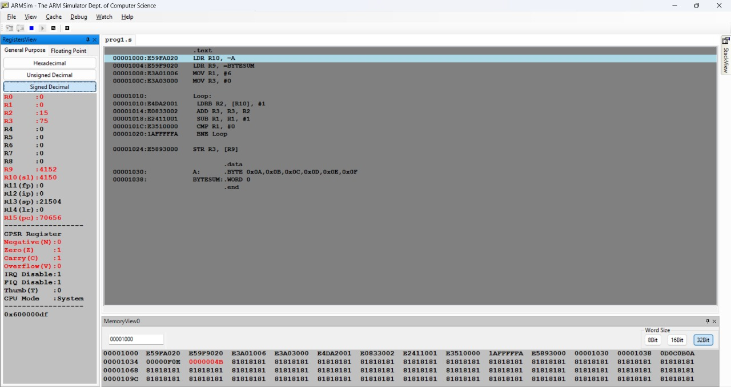

- Write an ALP using ARM7TDMI to generate a square Matrix given matrix A. The goal of the program is to modify a given square matrix A such that: If i == j (the row index equals the column index), set A[i][j] = 5,Otherwise, set A[i][j] = 0
The matrix size is provided as input (in this case, a 4x4 matrix).
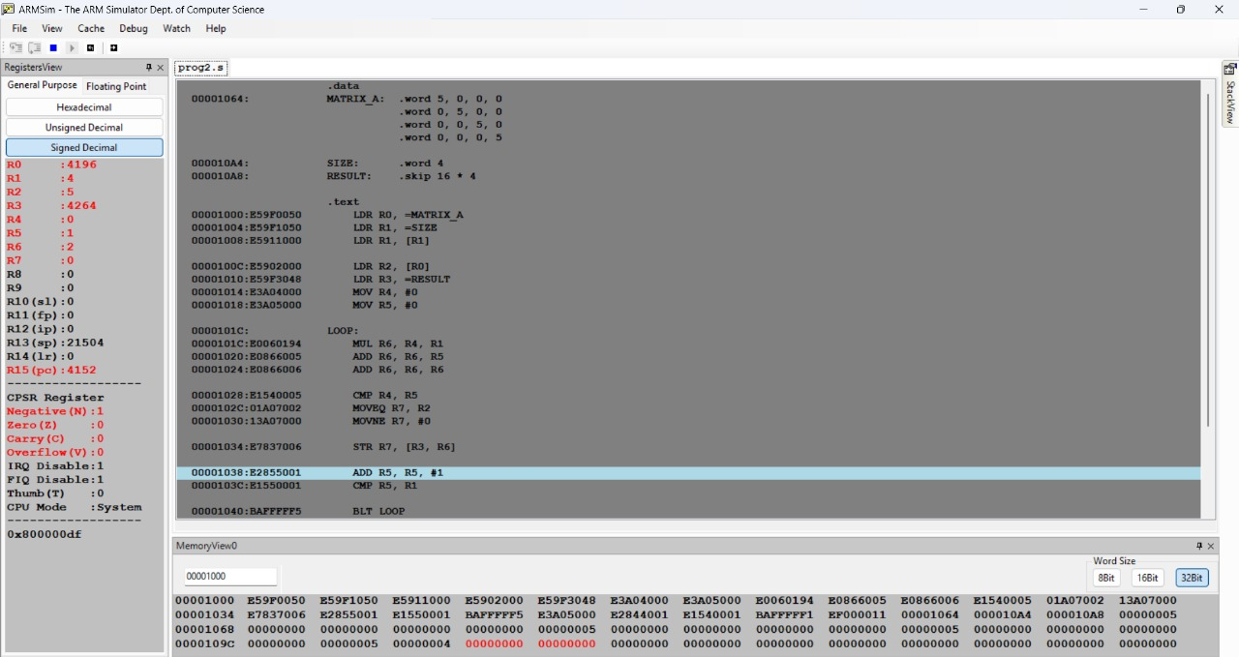

- Write an ALP using ARM7TDMI to perform 3*3 matrix addition.

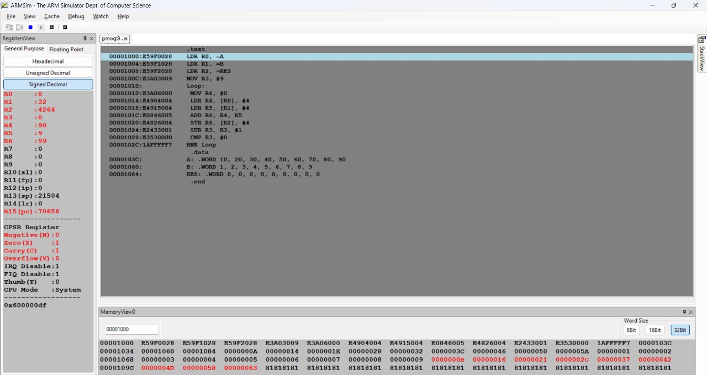

- Write an ALP using ARM7TDMI, for the given matrix arranged in column major order, find the index of an element if coordinates of a matrix is given and also find the address of the indexed element. (Using MLA instruction)

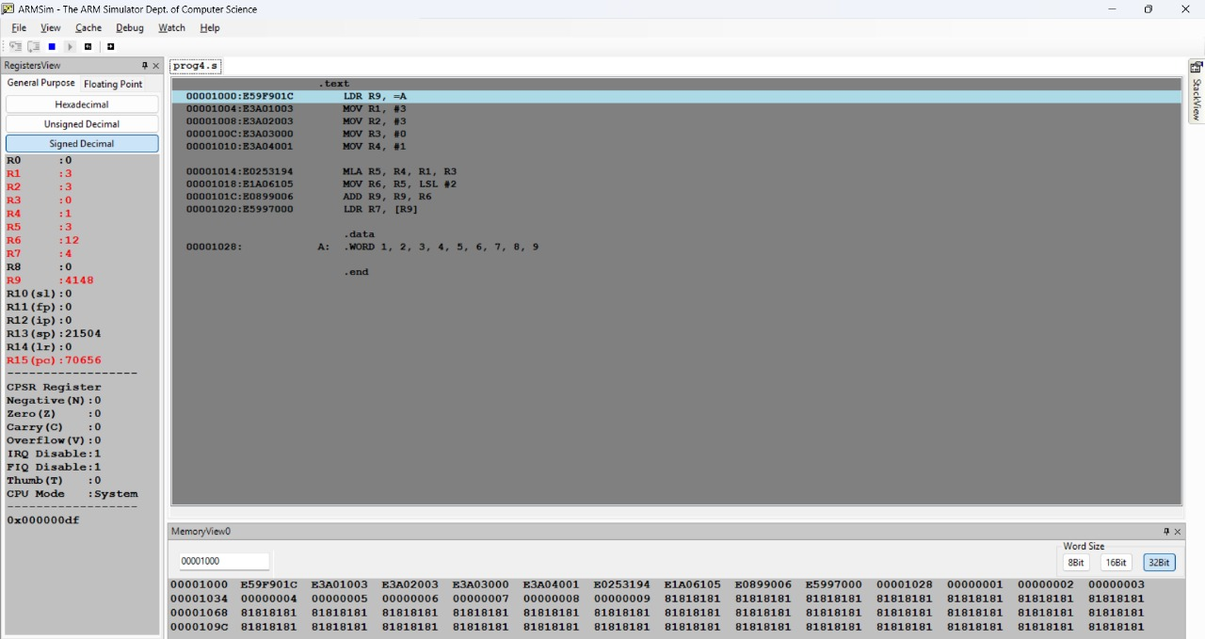

Assignment:

- Write an ALP using ARM7TDMI to reverse the elements stored in location A with location B
Before:
A:.word 1,2,3,4,5,6,7,8,9,10
After:
A:.word 10,9,8,7,6,5,4,3,2,1

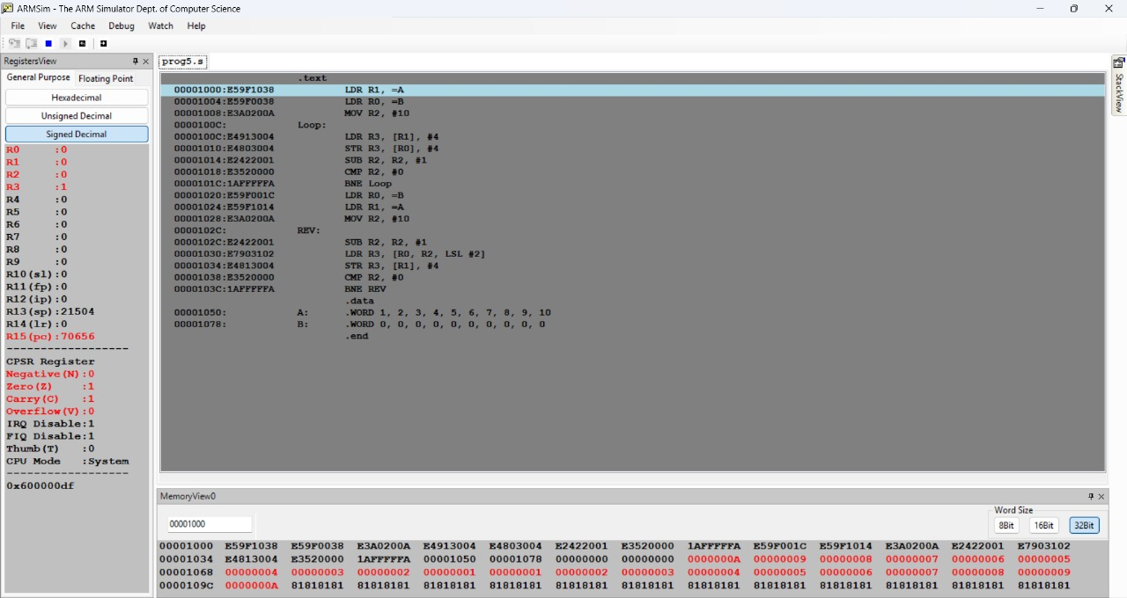

- Write an ALP using ARM7TDMI to find the sum of all the BCD digits of a given 32 bit number.

